**TRAVEL REPORT**

TITLE : 4th Batch Special Consular Mission (SCM) for

Plantation and Agricultural Sectors

TYPE OF ENGAGEMENT : Consular Mission

VENUE : Wilmar Plantations, Sandakan, Sabah

INCLUSIVE DATES : February 14-23, 2023

FTO NUMBER : 24-23

1. OBJECTIVE:

The main objective of the SCM is to help Filipino nationals working in the plantation and agricultural sectors in Sandakan, Sabah obtain regular employment by providing them with the proper documentation, which is the issuance of a passport. In order to achieve this objective, the following activities were done:

1. Processing of passport applications;
2. Preparation of Report of Birth (ROB) for unreported births;
3. Preparation of Certificate of Live Birth (COLB) for unregistered births for out-of-town reporting and registration to the concerned Local Civil Registry Office (LCRO);
4. Printing of available COLB from the PSA-CRS database and certification thereof; and
5. Philsys registration.
6. PARTICIPANTS:

In addition to the eight officials and personnel from the Philippine Embassy (PE) in Kuala Lumpur, Malaysia, there were eight delegates from the PSA who participated in the documentation process pursuant to Foreign Travel Order number 24-23. These are as follows:

1. Gerard A. Tolito, Registration Officer IV, RSSO-CAR
2. Joseph E. Estoesta, Statistician II, RSSO-Region 1
3. Maychelda S. Quillo, Registration Officer III, CRCSO-CRS-CRSD
4. Leonila U. Custodio, Registration Officer II, CRCSO-CRS-CRMD
5. Cherry B. Mitra, Registration Officer II, CRCSO-CRS-CRMD
6. Nathaniel P. Gonzales, Information Officer II, CTCO-ITDS-KMCD
7. Marc Joseph C. Dames, Information Systems Analyst II, PRO-SISS-ISMD
8. Cherry Mae D. Mapalad, Registration Officer I, PRO-ROS-RMD
9. OUTPUTS:
10. **Processing of COLB**

During the 10-day period from February 14-23, 2023, the six Civil Registration Processors (CRP) from the PSA team were able to serve 1,236 individuals in the processing of their COLBs as a requirement for their passport application. 64.11% of which have no record (Negative) in the PSA-Civil Registry System (CRS) database, and hence, were prepared with their respective COLBs following the procedure of Rule 20 of Administrative Order No. 1, series of 1993 for registration with the LCRO of the place of birth in the Philippines. On the other hand, 36.89% were found to have available birth record (Positive) in the PSA-CRS database. Thus, their respective birth certificates were printed and certified accordingly by the CRP. Table 1 below shows the daily accomplishment of the six CRPs.

**Table 1. Certificates of Live Birth Processed: Sandakan, Sabah, February 2023**

|  |  |  |  |
| --- | --- | --- | --- |
| Date | Negative | Positive | Total |
| February 14, 2023 | 86 | 38 | 124 |
| February 15, 2023 | 80 | 36 | 116 |
| February 16, 2023 | 120 | 20 | 140 |
| February 17, 2023 | 62 | 66 | 128 |
| February 18, 2023 | 63 | 45 | 108 |
| February 19, 2023 | 56 | 47 | 103 |
| February 20, 2023 | 72 | 64 | 136 |
| February 21, 2023 | 118 | 24 | 142 |
| February 22, 2023 | 53 | 78 | 131 |
| February 23, 2023 | 70 | 38 | 108 |
| TOTAL | 780 | 456 | 1,236 |
| Percentage to Total | 64.11 | 36.89 | 100.00 |
| Daily Average | 78 | 45.6 | 123.6 |

It is noteworthy, however, that the CRPs do not only process COLBs but also prepare the following requirements for passport application:

1. Identification (ID) card and Certificate of Employment of the plantation employee. For the dependents of the employee, a Certificate as a Dependent is prepared instead of an employment certificate;
2. Affidavit of how the applicant entered Sabah;
3. Passport application form; and
4. If the applicant is a minor, photocopy of the valid ID / passport of his/her mother.

Further, one CRP in the person of Mr. Nathaniel P. Gonzales is in-charge of providing documentations for the mission. The following are examples of these documentations, among others, which were posted on a regular basis in the PSA Facebook page:

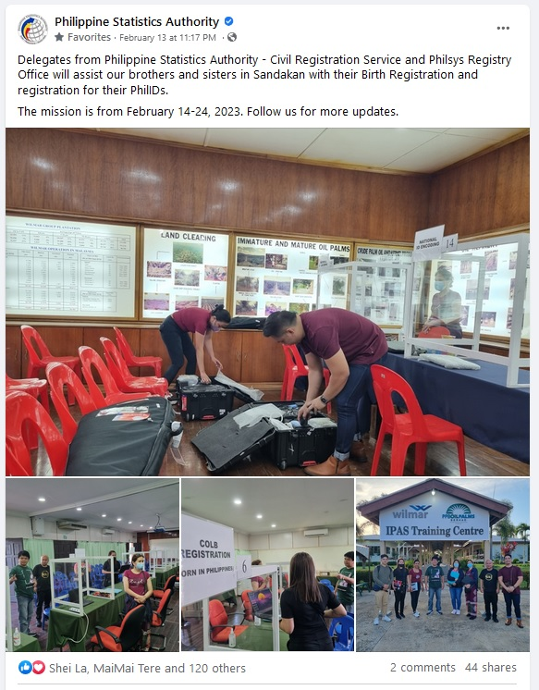

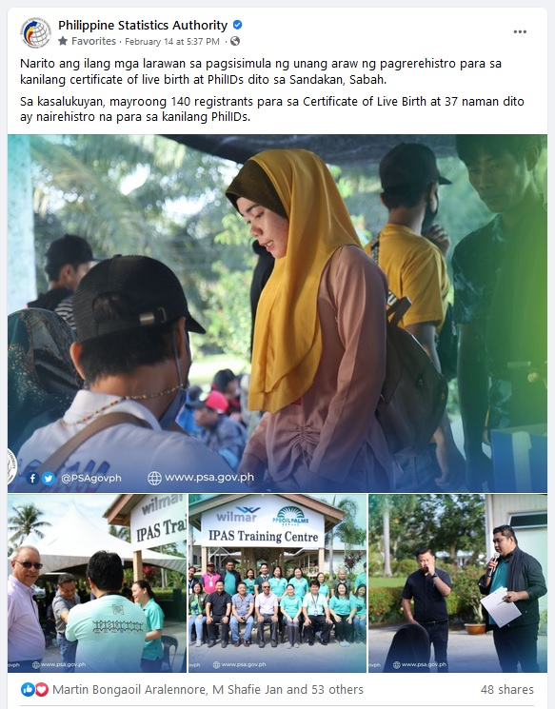

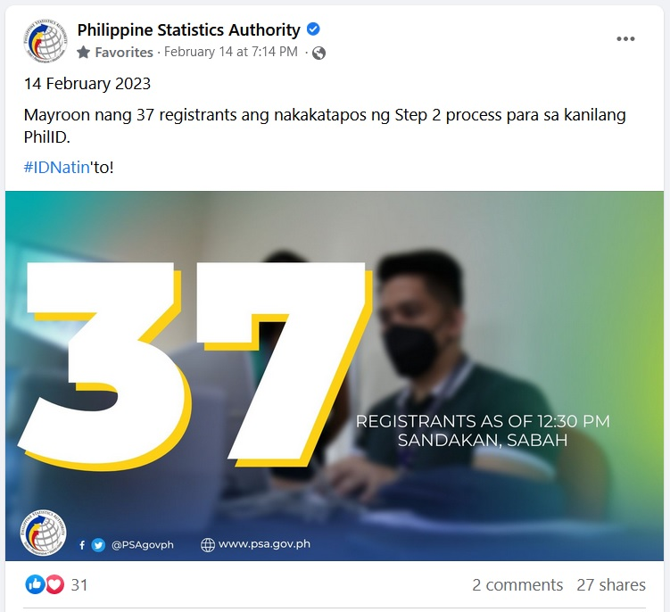

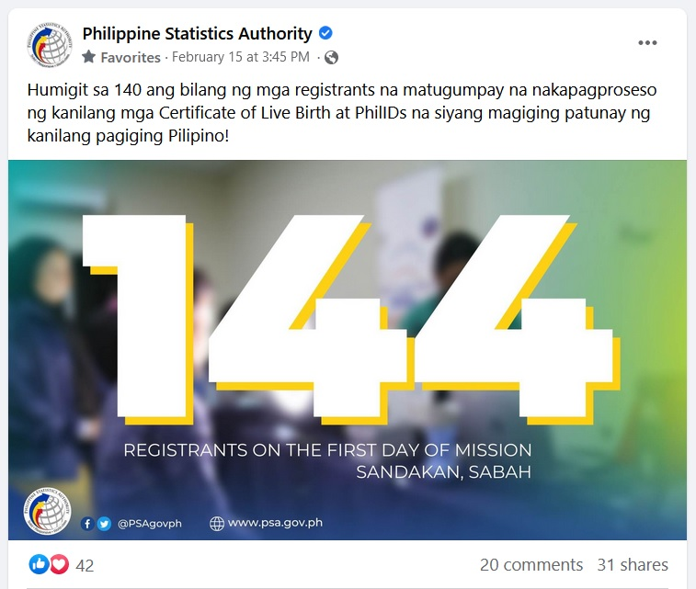

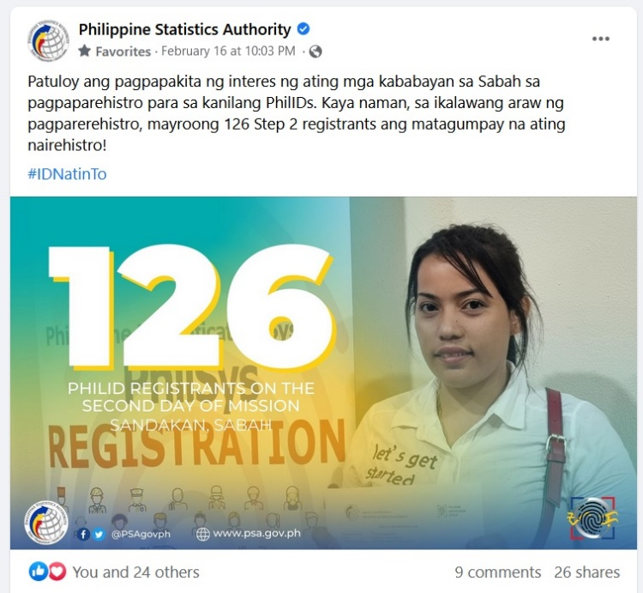

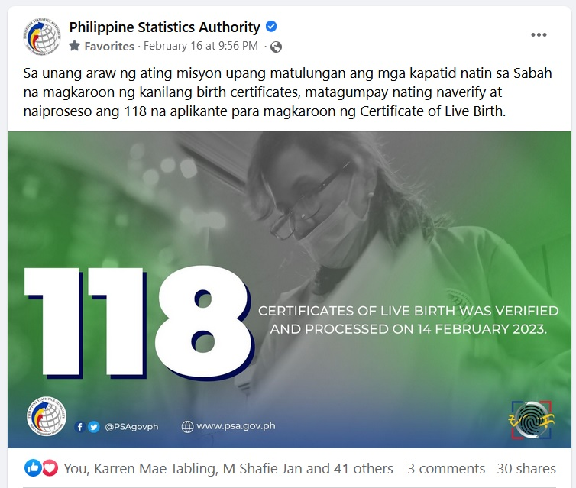

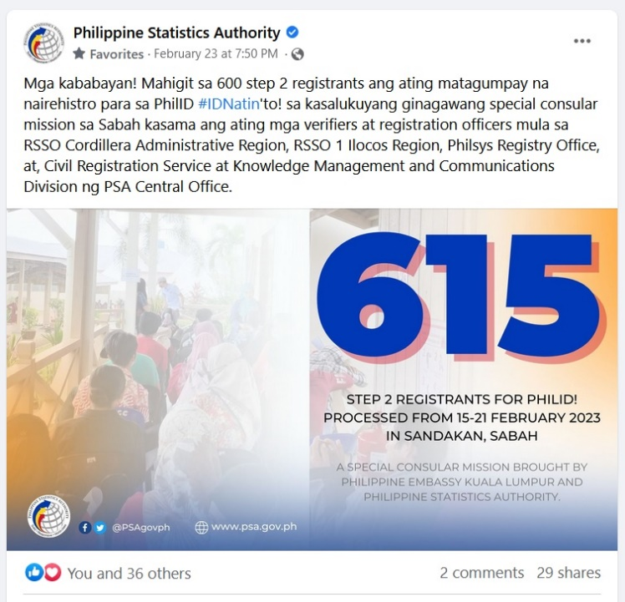

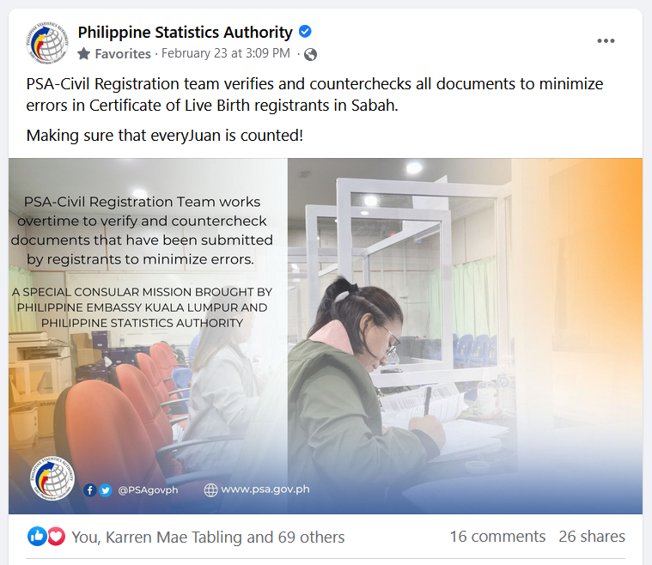

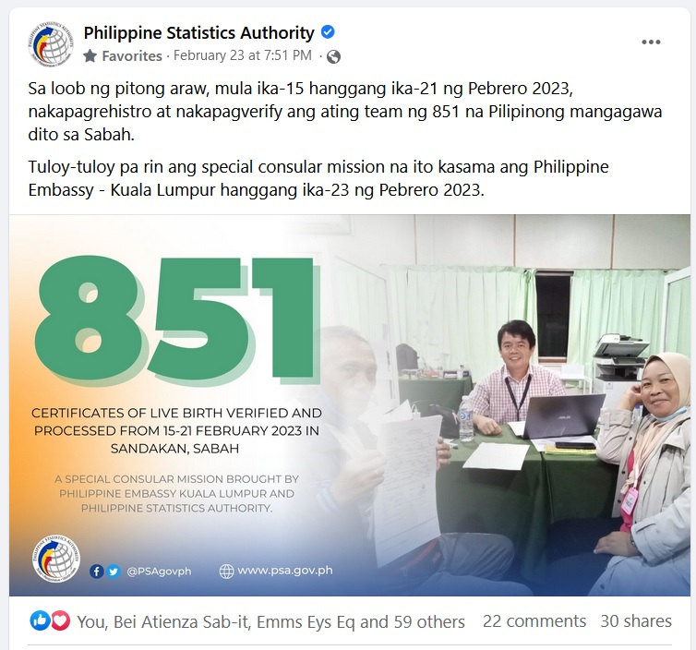

Table 2 below shows that there are 16 provinces and six Highly Urbanized Cities (HUC) with incidence of Unregistered Birth Events (UBE) for the employees including their dependents of the oil palm plantations in Sandakan, Sabah that participated in this SCM. The top five provinces with high incidence are Sulu, Tawi-Tawi, Zamboanga Del Sur (including Zamboanga City), Basilan and Zamboanga Sibugay. For the HUCs, only Zamboanga City has a high significant incidence of UBEs as compared to the other five.

**Table 2. Provinces and Highly Urbanized Cities with Unregistered Birth Events:**

**Sandakan, Sabah, February 2023**

|  |  |  |  |  |  |  |  |
| --- | --- | --- | --- | --- | --- | --- | --- |
| **Province** | **HUC** | **Number** | | | **Percentage to All UBE** | | |
| **Both Sexes** | **Male** | **Female** | **Both**  **Sexes** | **Male** | **Female** |
|  |  |  |  |  |  |  |  |
| **UBE** | | 780 | 467 | 313 | 100.00 | 59.87 | 40.13 |
|  | Caloocan City | 1 | 0 | 1 | 0.13 | 0.00 | 0.13 |
|  | Quezon City | 1 | 1 | 0 | 0.13 | 0.13 | 0.00 |
| Basilan |  | 94 | 53 | 41 | 12.05 | 6.79 | 5.26 |
| Cebu |  | 1 | 1 | 0 | 0.13 | 0.13 | 0.00 |
| Davao Del Sur | Davao City | 1 | 1 | 0 | 0.13 | 0.13 | 0.00 |
| Lanao Del Sur |  | 7 | 4 | 3 | 0.90 | 0.51 | 0.38 |
| Leyte |  | 1 | 1 | 0 | 0.13 | 0.13 | 0.00 |
| Misamis Occidental |  | 2 | 2 | 0 | 0.26 | 0.26 | 0.00 |
| Misamis Oriental | Cagayan de Oro City | 2 | 1 | 1 | 0.26 | 0.13 | 0.13 |
| Negros Oriental |  | 1 | 1 | 0 | 0.13 | 0.13 | 0.00 |
| Palawan |  | 5 | 1 | 4 | 0.64 | 0.13 | 0.51 |
| South Cotabato |  | 1 | 0 | 1 | 0.13 | 0.00 | 0.13 |
|  | General Santos City | 1 | 1 | 0 | 0.13 | 0.13 | 0.00 |
| Sultan Kudarat |  | 1 | 1 | 0 | 0.13 | 0.13 | 0.00 |
| Sulu |  | 311 | 184 | 127 | 39.87 | 23.59 | 16.28 |
| Surigao Del Norte |  | 1 | 1 | 0 | 0.13 | 0.13 | 0.00 |
| Surigao Del Sur |  | 1 | 1 | 0 | 0.13 | 0.13 | 0.00 |
| Tawi-Tawi |  | 178 | 99 | 79 | 22.82 | 12.69 | 10.13 |
| Zamboanga Del Norte |  | 22 | 16 | 6 | 2.82 | 2.05 | 0.77 |
| Zamboanga Del Sur |  | 14 | 7 | 7 | 1.79 | 0.90 | 0.90 |
|  | Zamboanga City | 89 | 57 | 32 | 11.41 | 7.31 | 4.10 |
| Zamboanga Sibugay |  | 45 | 34 | 11 | 5.77 | 4.36 | 1.41 |

Table 3 below shows the top 10 of the 77 cities (excluding HUCs) and municipalities that were found to have incidence of UBEs in this SCM. The municipalities of Jolo, Sulu and Bongao, Tawi-tawi have the highest number at 128 and 82, respectively. Only one city is included in this group, namely, Isabela City, Basilan having a number of UBEs at 25.

**Table 3. Top Ten Cities / Municipalities with Unregistered Birth Events:**

**Sandakan, Sabah, February 2023**

|  |  |  |  |  |  |  |  |
| --- | --- | --- | --- | --- | --- | --- | --- |
| **Province** | **City* / Municipality** | **Number** | | | **Percentage to All UBE** | | |
| **Both Sexes** | **Male** | **Female** | **Both**  **Sexes** | **Male** | **Female** |
|  |  |  |  |  |  |  |  |
| **UBE** | | 780 | 467 | 313 | 100.00 | 59.87 | 40.13 |
|  | |  |  |  |  |  |  |
| Sulu | Jolo | 128 | 76 | 52 | 16.41 | 9.74 | 6.67 |
| Tawi-Tawi | Bongao | 82 | 50 | 32 | 10.51 | 6.41 | 4.10 |
| Sulu | Pangutaran | 52 | 26 | 26 | 6.66 | 3.33 | 3.33 |
| Tawi-Tawi | Mapun | 47 | 24 | 23 | 6.03 | 3.08 | 2.95 |
| Sulu | Luuk | 34 | 24 | 10 | 4.36 | 3.08 | 1.28 |
| Basilan | Maluso | 33 | 17 | 16 | 4.23 | 2.18 | 2.05 |
| Basilan | Isabela City | 25 | 14 | 11 | 3.21 | 1.79 | 1.41 |
| Sulu | Siasi | 24 | 13 | 11 | 3.08 | 1.67 | 1.41 |
| Sulu | Patikul | 16 | 6 | 10 | 2.05 | 0.77 | 1.28 |
| Zamboanga Sibugay | Mabuhay | 15 | 9 | 6 | 1.92 | 1.15 | 0.77 |

* - Except Highly Urbanized Cities

In this particular SCM, there were 13 plantation companies that were catered. Of the total individuals served, the KLK Sawit Nusantara Berhad Plantation had the most number of employees including dependents served followed by the host plantation, Wilmar Plantations SDN BHD, with the Syarikat Sri Mengkabong SDN BHD plantation having the least number as shown in Table 4.

**Table 4. Plantations Served: Sandakan, Sabah, February 2023**

|  |  |  |  |
| --- | --- | --- | --- |
| Plantation | Employees Served (Including Dependents) | | |
| Number | Percent | Rank |
| KLK Sawit Nusantara Berhad | 358 | 30.73 | 1 |
| Wilmar Plantations SDN BHD | 246 | 21.11 | 2 |
| Ladang Sri Harapan (Sabah) SDN BHD | 159 | 13.65 | 3 |
| Tung Hup Enterprises SDN BHD | 78 | 6.70 | 4 |
| Borneo Samudera SDN BHD (Sawit Kinabalu) | 75 | 6.44 | 5 |
| IOI Plantation Services SDN BHD | 74 | 6.35 | 6 |
| KEBACO SDN BHD | 54 | 4.64 | 7 |
| Aspirasi Kristal (M) SDN BHD | 38 | 3.26 | 8 |
| Sabahebat SDN BHD | 36 | 3.09 | 9 |
| Ikatan Kayangan SDB BHD | 21 | 1.80 | 10 |
| Karangan Agriculture SDN BHD | 11 | 0.94 | 11 |
| Borneo Crops SDN BHD | 10 | 0.86 | 12 |
| Syarikat Sri Mengkabong SDN BHD | 5 | 0.43 | 13 |
| TOTAL | 1,165 | 100.00 |  |

The difference of 71 individuals between the totals in Table 1 and Table 4 are those applicants that went directly to the PE team for the renewal of their passport but were referred to the CRPs for the verification and printing of their COLB or ROB. Hence, their respective employers and demographic information were not recorded.

Table 5 shows that there are more males served in this SCM than females. Six out of ten individuals served are males while almost four out of ten are females.

**Table 5. Client’s Demographic Profile: Sandakan, Sabah, February 2023**

|  |  |  |  |  |  |  |
| --- | --- | --- | --- | --- | --- | --- |
| **Age Group** | **Number** | | | **Percent to All Ages** | | |
| **Both Sexes** | **Male** | **Female** | **Both Sexes** | **Male** | **Female** |
| All Ages | 1165 | 715 | 450 | 100.00 | 61.37 | 38.63 |
| 0 – 4 | 24 | 12 | 12 | 2.06 | 1.03 | 1.03 |
| 5 – 9 | 55 | 30 | 25 | 4.72 | 2.58 | 2.15 |
| 10 – 14 | 62 | 28 | 34 | 5.32 | 2.40 | 2.92 |
| 15 – 19 | 122 | 75 | 47 | 10.47 | 6.44 | 4.03 |
| 20 – 24 | 187 | 112 | 75 | 16.05 | 9.61 | 6.44 |
| 25 – 29 | 180 | 123 | 57 | 15.45 | 10.56 | 4.89 |
| 30 – 34 | 149 | 105 | 44 | 12.79 | 9.01 | 3.78 |
| 35 – 39 | 129 | 75 | 54 | 11.07 | 6.44 | 4.64 |
| 40 – 44 | 101 | 58 | 43 | 8.67 | 4.98 | 3.69 |
| 45 – 49 | 62 | 39 | 23 | 5.32 | 3.35 | 1.97 |
| 50 – 54 | 64 | 38 | 26 | 5.49 | 3.26 | 2.23 |
| 55 – 59 | 25 | 16 | 9 | 2.15 | 1.37 | 0.77 |
| 60 – 64 | 4 | 3 | 1 | 0.34 | 0.26 | 0.09 |
| 65 – 69 | 0 | 0 | 0 | 0.00 | 0.00 | 0.00 |
| 70 and above | 1 | 1 | 0 | 0.09 | 0.09 | 0.00 |
|  |  |  |  |  |  |  |
|  | **Number** | | | **Percent to All Ages** | | |
| **Both Sexes** | **Male** | **Female** | **Both Sexes** | **Male** | **Female** |
| School Age Group | 426 | 245 | 181 | 36.57 | 21.03 | 15.54 |
| 5 | 9 | 5 | 4 | 0.77 | 0.43 | 0.34 |
| 6 – 11 | 72 | 36 | 36 | 6.18 | 3.09 | 3.09 |
| 12 – 15 | 50 | 25 | 25 | 4.29 | 2.15 | 2.15 |
| 16 – 17 | 21 | 6 | 15 | 1.80 | 0.52 | 1.29 |
| 18 – 24 | 274 | 173 | 101 | 23.52 | 14.85 | 8.67 |

The youngest client served is three months old while the oldest is 70 years of age. The average age of the 1,165 individuals served is 29 with a median age of 28. Clients aged 19 have the most number of counts at 52 while the age group 20-24 had the most count at 187.

From Table 5 above, 36.57% belong to the school age population. There are 274 individuals aged 18 to 24 years old who are supposed to be attending school, particularly college, as they belong to the school age population (5 to 24 years old) but are already working in the palm oil plantations in Sandakan, Sabah.

1. **Philsys Registration**

During the same ten-day period, the two PSA team members who are in-charge for the Philsys registration were able to register 1,293 individuals. Table 6 below shows their daily output with the eighth day having the highest number of individuals registered at 161 while the sixth day has the least number at 90 individuals.

**Table 6. Individuals Registered to Philsys: Sandakan, Sabah, February 2023**

|  |  |
| --- | --- |
| Date | Total |
| February 14, 2023 | 133 |
| February 15, 2023 | 133 |
| February 16, 2023 | 160 |
| February 17, 2023 | 112 |
| February 18, 2023 | 111 |
| February 19, 2023 | 90 |
| February 20, 2023 | 133 |
| February 21, 2023 | 161 |
| February 22, 2023 | 150 |
| February 23, 2023 | 110 |
| TOTAL | 1,293 |
| Daily Average | 129.3 |

For the 1,293 individuals who registered for the PhilID, their average and median age is the same with the CRP clients at 29 and 28, respectively. Also, registrants aged 19 have the most number of counts at 67. However, the age range of clients for the Philsys registration is 5 to 70.

The larger volume of registrants for the PhilID at 1,293 vis-à-vis the number individuals served by the CRPs at 1,236 is attributed to those passport applicants who have complete requirements at hand. Hence, they were not referred back to the CRPs for the verification and issuance of their COLB or ROB.

1. **Others**

On the evening of February 19 and during the lunch break of February 20, both the PE and the PSA teams were ushered by the host plantation manager and employees to tour the plantation area and visit the housing, educational and other facilities provided to their workers.

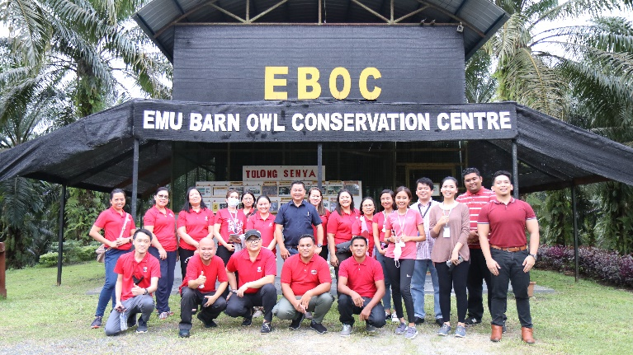

*February 19 – The center is where the plantation grow and train owls to catch rats*

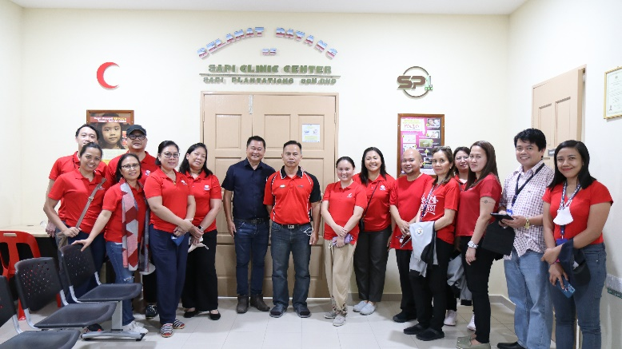

*February 19 – The clinic center*

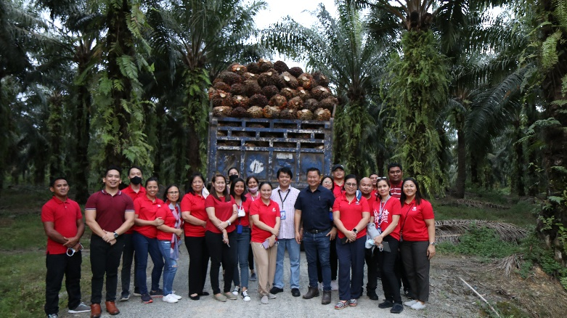

*February 19 – Harvested palm fruits that were already loaded on a truck*

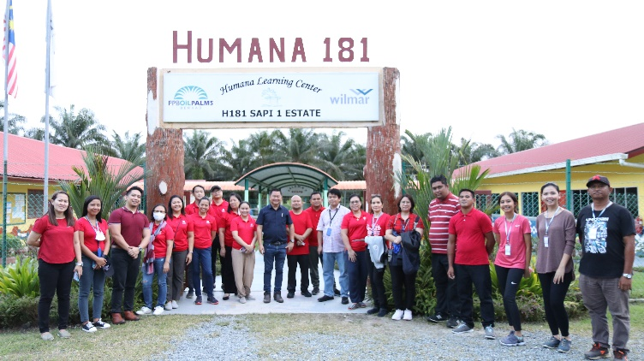

*February 19 – Learning center for the children of plantation workers*

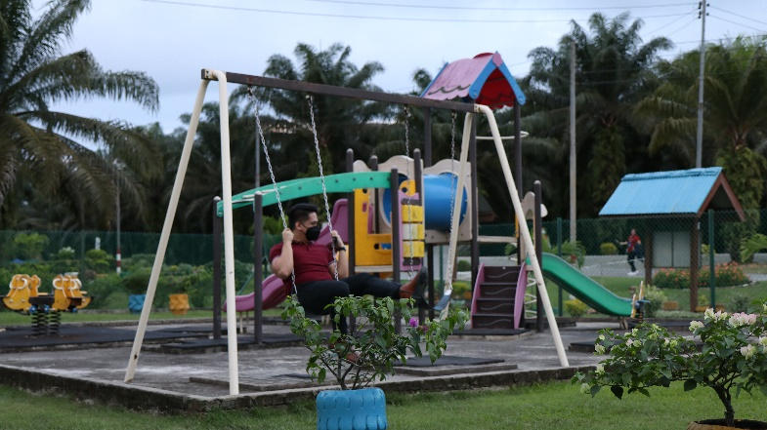

*February 19 – Play area/park for the school goers as tested by one of the members of the PSA team*

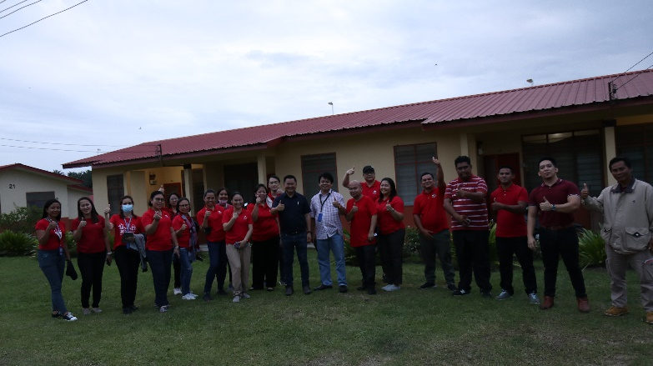

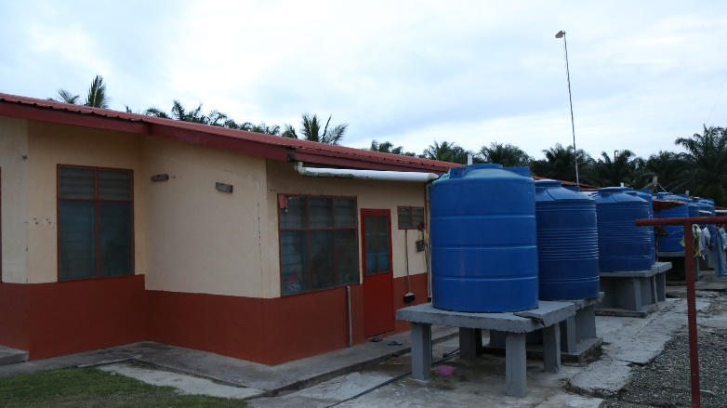

*February 19 – The housing facilities for the plantation workers*

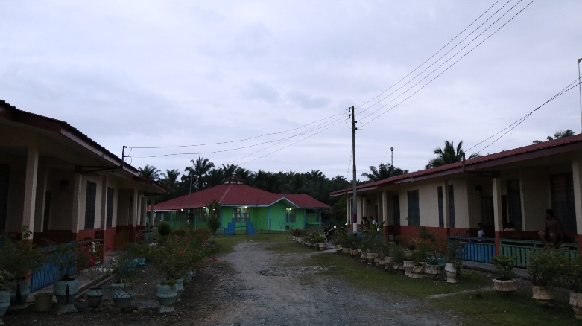

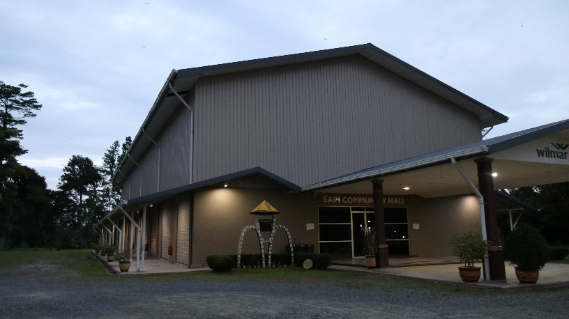

*February 19 – Community hall*

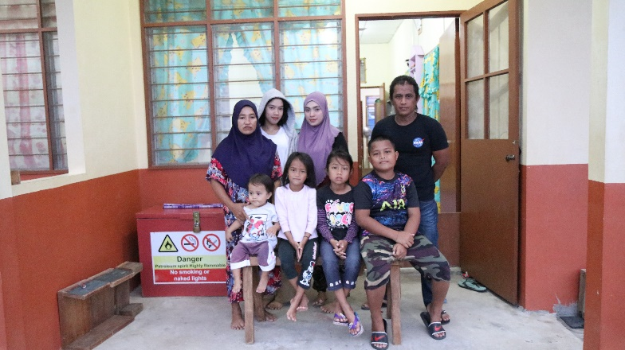

*February 20 – Family of a worker in his housing unit provided by the plantation company*

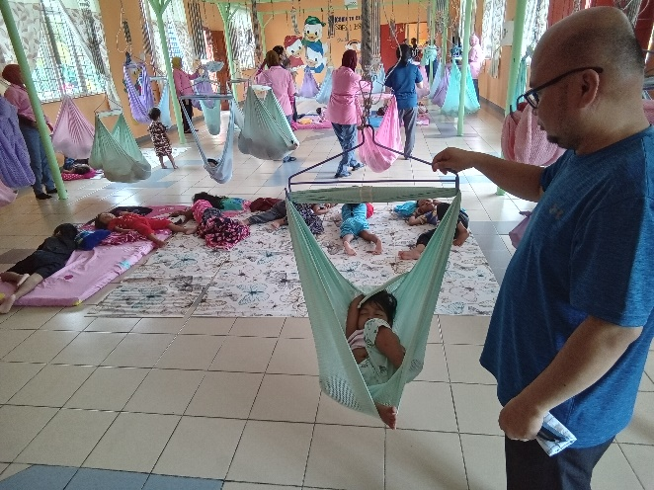

*February 20 – Daycare center for the toddlers of the plantation workers*

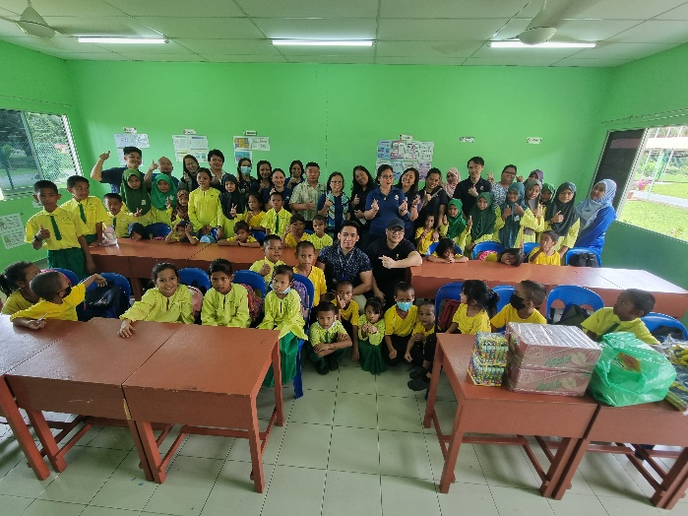

*February 20 – Children of plantation workers who are attending pre-school and elementary grade school*

1. KEY LEARNINGS / EXPERIENCES
2. Extracting of personal information from registrants who do not know their personal information, forgot about it or who do not want to reveal/provide the true information for registration.
3. Managing stress due to lack of sleep and fatigue.
4. Establishing and sustaining good working relationships with the PE officials and personnel as well as the plantation managers and employees.
5. ACTION POINTS / RECOMMENDATION
6. Provision of additional CRPs to lessen the daily working hours of around 12 hours in order to prevent exhaustion and stress.

As per suggestion of Vice-Consul Janice Rivera, this can be attained if the PSA-Philsys Registry Office will shoulder the cost for the two PRO delegates who will conduct the Philsys registration. In this way, the original six CRPs will increase to eight.

In this particular SCM, the participating plantations shouldered the costs for the eight PSA delegates (6 CRPs and 2 for Philsys registration) and will continue to do so in the next special consular missions.

1. Monitoring of the forwarded COLBs to the concerned Provincial Statistical Office / LCRO as to the status of registration and of the submission of a copy to the Office of the Civil Registrar General for uploading in the PSA-CRS database and for archiving.
2. The consolidated databases / list of registrants in the previous SCMs should be provided to the current PSA team for reference in the event of non-availability in the PSA-CRS database of the COLBs prepared during such previous SCMs.
3. Although the main goal of the SCM is to issue a passport to the plantation workers in order for their employment to be regularized, a clarification is suggested to be sought in cases where a plantation worker seeks for the renewal of his/her passport but with erroneous information in the DFA database and that he/she has no record of birth in the PSA-CRS database such that the CRPs will prepare his/her COLB to contain the correct information for registration.
4. Without prejudice to the capability of any PSA Team Lead (TL), the next TL for the PSA delegates for the succeeding missions should come from any of the delegates from the previous missions. This is for him/her to have a full knowledge and understanding of every aspect of the tasks of the mission. This is in consideration that these tasks are not only PSA related functions but also tasks related to the passport processing and to other personal needs of the team.
5. PHILIPPINE EMBASSY AND PHILIPPINE STATISTICS AUTHORITY TEAMS IN ACTION

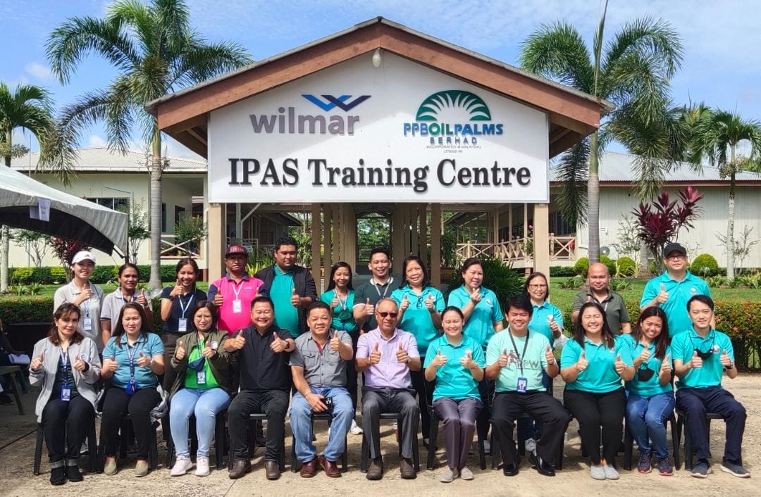

PSA and PE teams together with the managers and employees of the host plantation

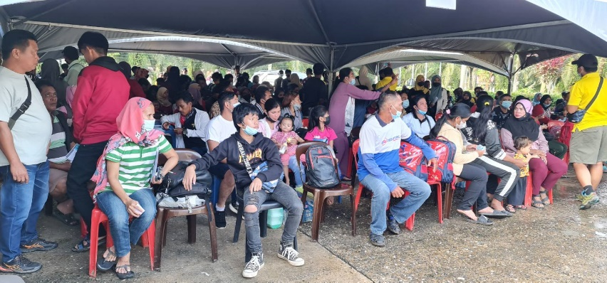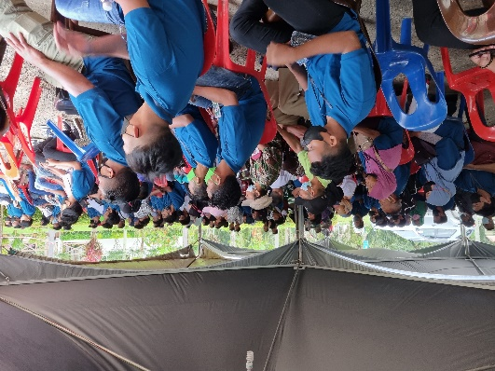

*(Above and below)* Our clients with their children who patiently wait for their turn to be served even until late at night

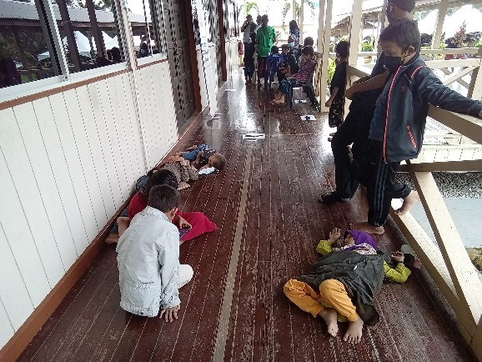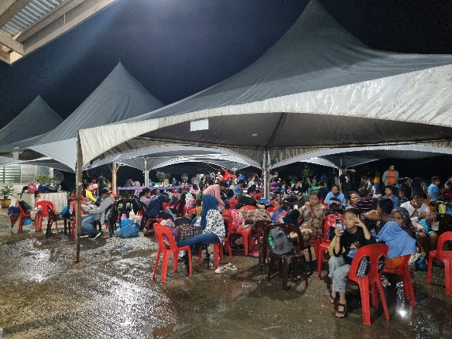

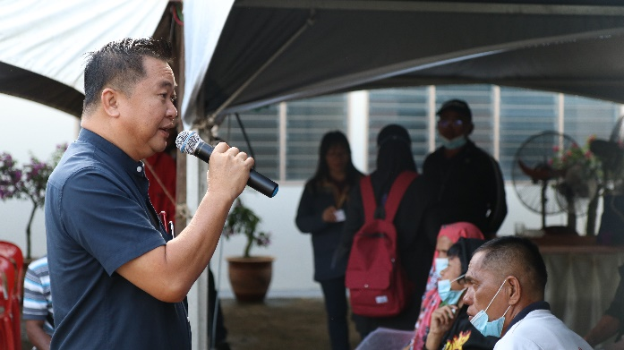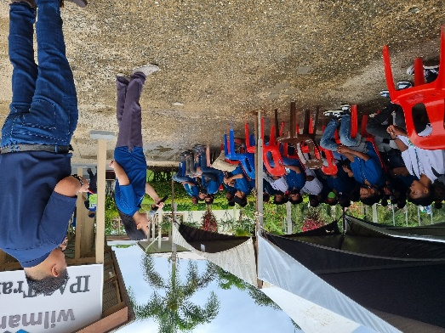

Vice-Consul Janice P. Rivera and Mr. Peter Mojiun, Senior Manager, Wilmar Plantations, giving their daily orientations to the clients every morning

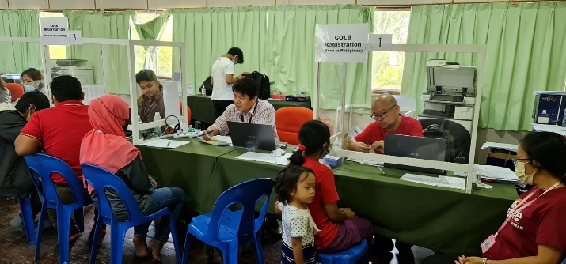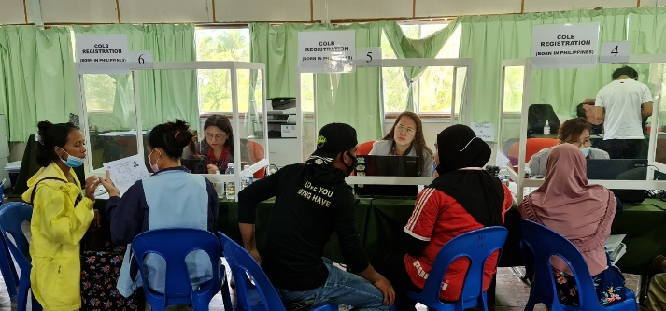

Counters 1 to 6: PSA CRPs (from right to left): Joseph E. Estoesta, Gerard A. Tolito, Nathaniel P. Gonzales,

Leonila U. Custodio, Cherry B. Mitra and Maychelda S. Quillo

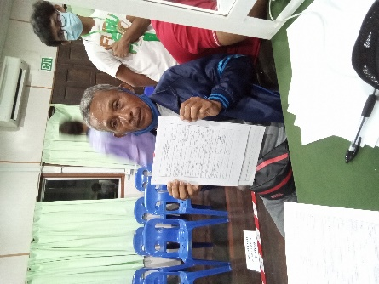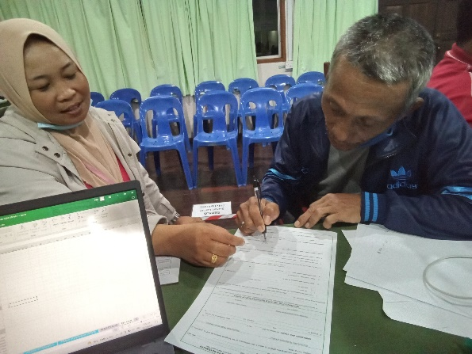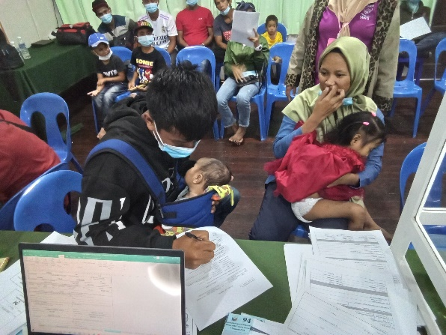

Worker-registrants signing their COLBs including that of their dependents

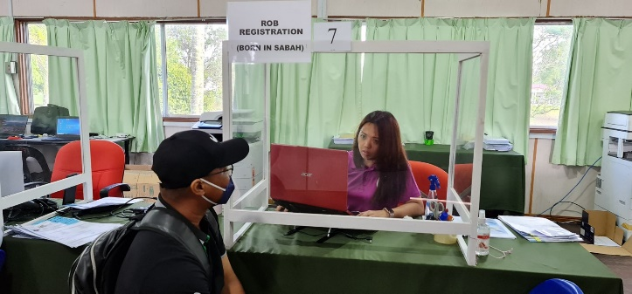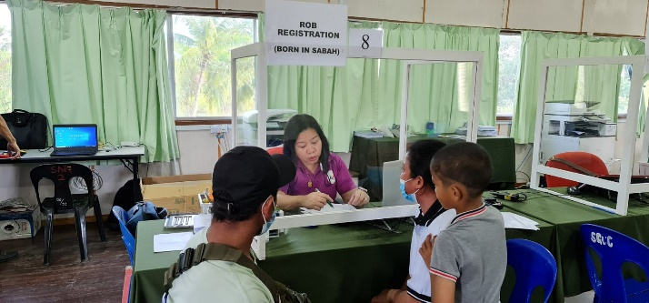

Counters 7 and 8, PE CRPs for Report of Birth (from left to right): Miriam Cruz, Lailani Dahimuddin

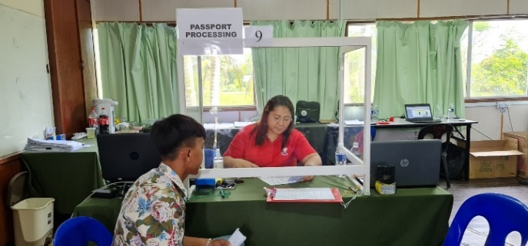

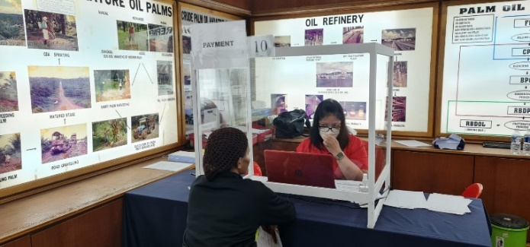

Counter 10, Payment: Alicia de Jesus Pandapatan

Counter 9, Passport processing: Josefa Cabañero

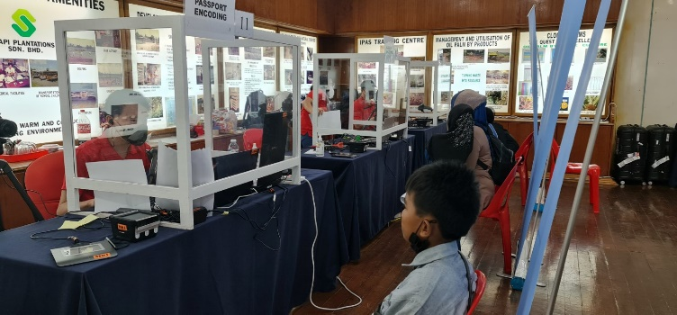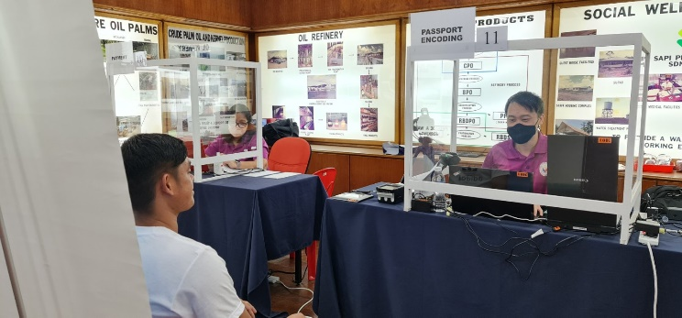

Counters 11 to 13, Passport Encoding: Noel Christian Tan, Claribel Barit, Joel Rodrigo

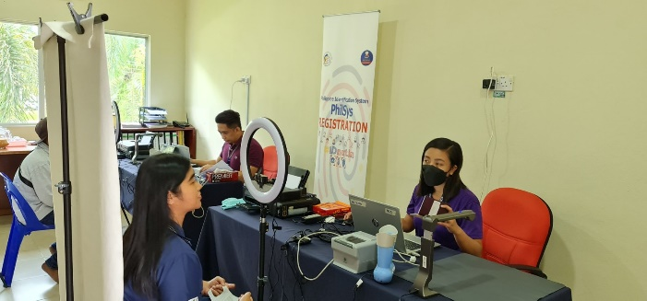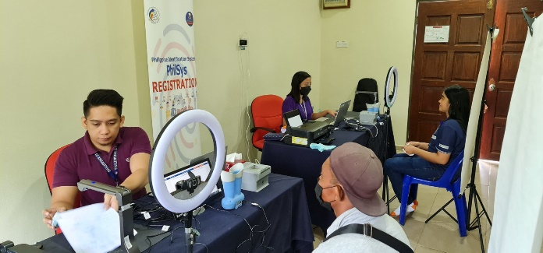

Counters 14 and 15, Philsys Registration: Marc Joseph C. Dames, Cherry Mae D. Mapalad

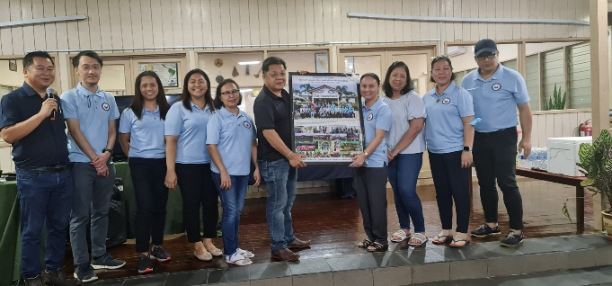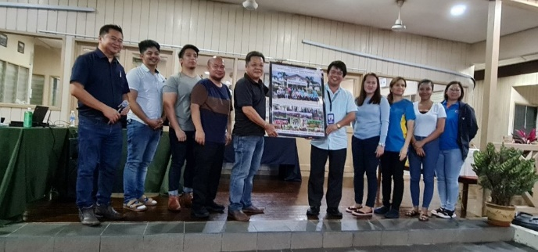

Closing Program (February 23): PSA and PE Teams receiving their token of appreciation from the host plantation

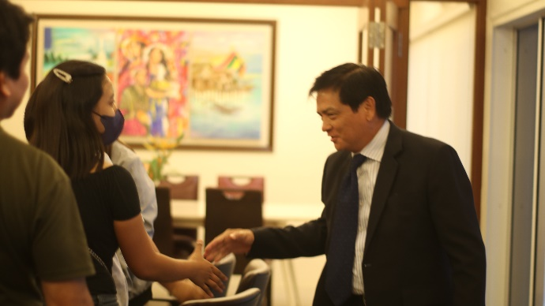

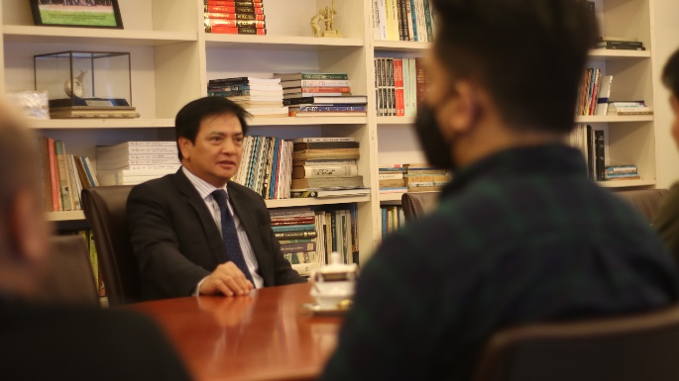

February 24: Courtesy Call of the PSA Team with Ambassador Charles C. Jose

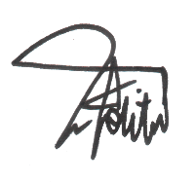SUBMITTED BY:



GERARD A. TOLITO JOSEPH E. ESTOESTA

Registration Officer IV Statistician II

RSSO-CAR RSSO-Region 1



MAYCHELDA S. QUILLO LEONILA U. CUSTODIO

Registration Officer III Registration Officer II

CRCSO-CRS-CRSD CRCSO-CRS-CRMD





CHERRY B. MITRA NATHANIEL P. GONZALES

Registration Officer II Information Officer II

 CRCSO-CRS-CRMD CTCO-ITDS-KMCD



MARC JOSEPH C. DAMES CHERRY MAE D. MAPALAD

Information Systems Analyst II Registration Officer I

PRO-SISS-ISMD PRO-ROS-RMD